Project Proposal

On

**Matrimonial Website**



Name: Anish Budhathoki

NCC ID:00168755

Computing Project

Level 5 Diploma in Computing

Softwarica College of IT and E-Commerce

Kathmandu, Nepal

Date of Submission: 04/01/2019

Submitted to: Kiran Rana

Table of Contents

Introduction 1

1.1 Project Introduction 1

1.2 Justification for project 1

1.2.1 Background of the project 1

1.2.2 Problem Statement 1

1.3 Description of the project 2

1.3.1 Features 2

2.Project Scope 3

2.1 Scope and Limitation of project 3

2.2 Aims and Objectives 3

3. Development Methodology 4

3.1 Methodology used 4

3.2 Design Pattern 5

4. Work Breakdown Structure(WBS) / Scheduling 7

4.1 Work Breakdown Structure 7

4.2 Milestones 8

4.3 Scheduling/Gantt Chart: 9

5. Risk Management 11

6. Configuration Management 12

7. Conclusion of project 14

References 15

List of Figures:

Figure 1 Waterfall Model 4

Figure 2 MVC Design Pattern 5

Figure 3 3-tier Architecture 6

Figure 4 Work Break Down(WBS) 7

Figure 5 Gantt Chart 9

Figure 6 Graphical Representation of Gantt Chart 10

Figure 7 Tree structure 12

Figure 8 File Repository in GitHub 13

# Introduction

## Project Introduction

Matrimonial Website is an online service which is use to place wedding service providers on one platform. It is a kind of Business-to-Consumer portal to provide clientage to the business for more business and more profit. It helps to find the right partner for the users and match making according to their choices.

In Today Scenario it’s a tuff task for everyone to get the work properly on time because everyone having lack of time. So, it is a necessity and an urging need to apply the information technology for matrimonial services.

### Justification for project

The development of matrimonial website is to find right partners to marry them. Other reasons are given below:

* To provide relevant and required information.
* To store information about the users.

# Background of the project

The project that we are going to work on is about matrimonial. It helps male/female to find their life partners according to their preferences. This will save their time. They can also have many choices under a single system. They can also send invitation to their preferred once and can rate them according to their choice.

# Problem Statement

After doing some analysis, there are some problem statement are also identified. This system allows the user to contact their partners easily and the third party will not involve. It also saves the time of the user and can find the required partners for them. It provides interaction from any region. It provides a flexible system to the users. The convention method used paper so it uses more resources and it cannot give the user satisfaction they want.

# Description of the project

The website that I am going to build is a matrimonial website. The purpose for building this website is to find the right partners for each other and marry them. The website will provide the information of the person like religion, caste, occupation, qualification. And other person can choose based on their interest. The website is going to be developed by using PHP (Hypertext Preprocessor) programming language. For the database MySQL is going to be used. Also Laravel framework will be used.

## Features

Features of the matrimonial websites are:

* **Login and Registration of the user:**

Users can register their profile by entering their information and login with username and password.

* **CRUD Operations for adding, updating, deleting and retrieving the operation:**

Users can perform CRUD operations for updating their profile, deleting their profile and viewing their information.

* **Messaging to the matched preferences:**

The user can message to other user which they like and want to talk with them.

* **Viewing others profile:**

User can view the required information about other users.

* **Admin Control:**

Admin can remove the user and can make changes to the system. Also can retrieve all the information.

* **Searching user profile:**

Users can search other users profile by their name and other information.

* Rating other users:

Users can rate other users profile respectively.

* **Matchmaking with the preferred ones:**

Users can do matchmaking with the other person they choose.

* **Sending invitation to other users:**

Users can send the invitation to visit their profile and rate them.

# 2.Project Scope

## 2.1 Scope and Limitation of project

The main motive of the project is to find the right partners of their preferences. The requirements for the projects are all listed out. This project will save the time of different users and make it easier to search the partners of their choices. It also records accurate and proper data. The resources, time and budget are allocated for the project.

**Limitations of project are:**

* Payment method is not available.
* Need some computer knowledge to use it.
* Cannot login through social media accounts.

# 2.2 Aims and Objectives

**Aims:**

* To provide a user-friendly environment.
* To provide best way for matchmaking.
* To show detailed information of the person regarding his/her information.
* To fulfill need of the individuals which cannot find their life partners.
* To make simple and responsive design.

**Objectives:**

* To store the data of user securely.
* To analyzing the activities of the consumer.
* To maintaining and upgrading the quality of site.
* To find the weakness and capabilities of the site.

# 3. Development Methodology

## 3.1 Methodology used

Methodology that is chosen for this project is Waterfall model. It is a classic approach to the systems development method that is linear and sequential. The right selection of methodology leads to the successful project.

Waterfall model is used because it is a sequential design process in which progress is seen as flowing steadily downwards (like a waterfall) through phases. In a Waterfall model, each phase must complete to begin the other one and there is no overlapping. (Anon., 2019)

**Stages of the Waterfall model are:**

* Requirement Analysis
* Design
* Implementation
* Testing
* Maintenance

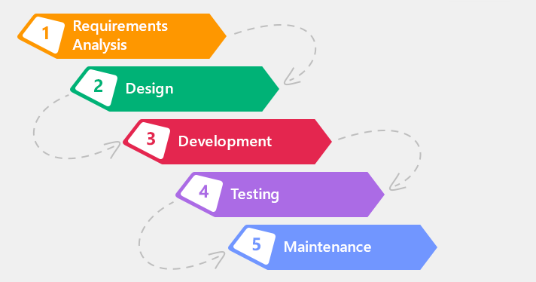

Figure Waterfall Model

### 3.2 Design Pattern

Design pattern describes a general solution to a design problem that recurs repeatedly in many projects. It uses a formal approach to describing a design problem its proposed solution, and any factors that might affect the problem or the solution.

Design pattern used in this project is MVC design pattern. Model-View-Controller(MVC) helps to separate an application into three main logical components the model, the view and the controller. It is used in this project because:

* Faster development process.
* Ability to provide multiple views.
* Modification does not affect the entire model.

**Logical components of MVC are:**

* Model: It holds raw data.
* View: It is the collection of functions that interact with users.
* Controller: It acts as link between model and view. (Anon., 2019)

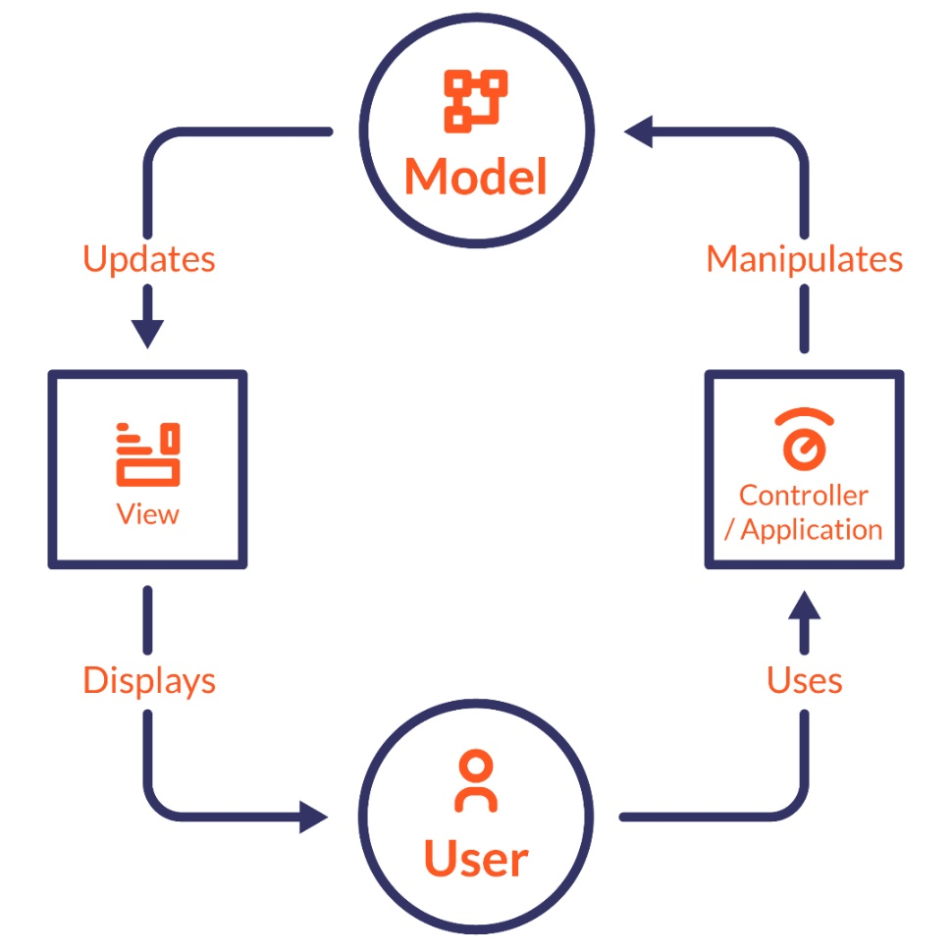

Figure 2 MVC Design Pattern

#### 3.3 System Architecture

System Architecture is the conceptual model that defines the structure, behavior and more views of a system. 3-tier architecture is being used for this project (Anon., 2019). 3-tier architecture is a type of software architecture which is composed of three layers of logical computing which are used most often in client-server system. It improves the development efficiently and helps for the faster development.

**Three layers of 3-tier architecture:**

* Presentation Tier: It is a front end layer and consist of the user interface.
* Application Tier: It contains the functional business logic.
* Data Tier: It comprises of the database system and data access layer.

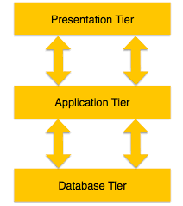

Figure 3 3-tier Architecture

# 4. Work Breakdown Structure(WBS) / Scheduling

## 4.1 Work Breakdown Structure

Work Breakdown Structure(WBS) is a hierarchical tree structure that outlines the project and break it downs into smaller, more manageable portions. The main objective of WBS is to make a project manageable. So that the smaller chunks of work can be done simultaneously and efficiently.

Reason for WBS:

* It helps to allocate resources and managing them.
* It connects all the elements logically.

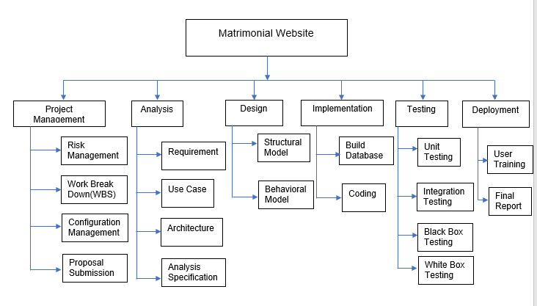

Figure 4 Work Break Down(WBS)

### 4.2 Milestones

Milestone is a tool that is used to delineate a point in a project schedule. These points can note start and finish of a major phase of work. It is used to symbolize anything that has started or finished, though it’s a primarily scheduling tool.

|  |  |
| --- | --- |
| **Milestones** | **Date** |
| **Project Management**  Risk Management  WBS  Configuration Management  Proposal Submission | 12/21/2018(14 days)  12/21/2018-12/25/2018  12/26/2018-12/27/2018  12/28/2018-12/31/2018  01/01/2019-01/03/2018 |
| **Analysis**  Requirement analysis  Use Case  Architecture (Initial Class Diagram)  Analysis Specification | 01/04/2019(25 days)  01/04/2019-01/10/2019  01/11/2019-01/15/2019  01/16/2019-01/22/2019  01/23/2019-01/28/2019 |
| **Design**  Structural Diagram  Behavioral Diagram  UI Design  Database Design (ER , Data Dictionary) | 01/29/2019(30 days)  01/29/2019-02/05/2019  02/06/2019-02/11/2019  02/12/2019-02/19/2019  02/20/2019-02/27/2019 |
| **Implementation**  Building Database  Coding | 02/28/2019(32 days)  02/28/2019-03/09/2019  03/10/2019-03/31/2019 |
| **Testing**  Unit Testing  Integration Testing  Black box Testing  White box Testing | 04/01/2019(10 days)  04/01/2019-04/02/2019  04/03/2019-04/05/2019  04/06/2019-04/07/2019  04/08/2019-04/10/2019 |
| **Deployment**  User Training  Final Report | 04/11/2019(10 days)  04/11/2019-04/16/2019  04/1/2019-04/20/2019 |

**Description of milestones:**

* Project Management: 14 days are allocated for project management.
* Analysis: 25 days are allocated for analysis.
* Design: 30 days are allocated for design.
* Implementation: 32 days are allocated for implementation.
* Testing: 10 days are allocated for testing.
* Deployment: 10 days are allocated for deployment.

# 4.3 Scheduling/Gantt Chart:

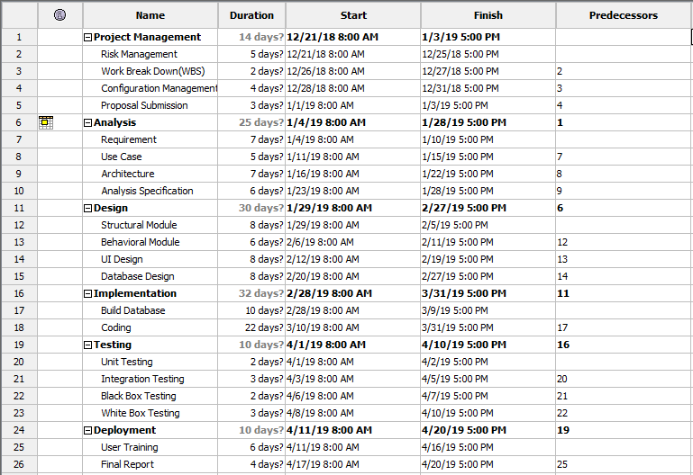Scheduling is the process of developing, maintaining and communicating schedules for time and resource. A schedule is a timetable for the project.

Figure 5 Gantt Chart

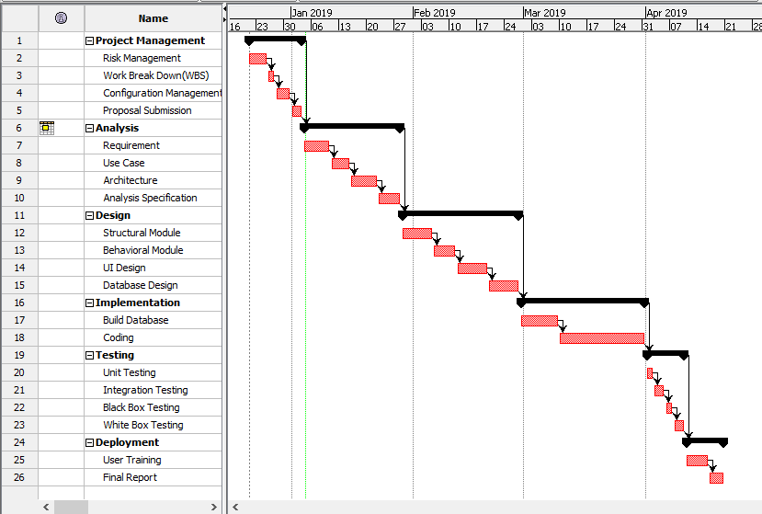Gantt Chart is a chart which shows the activities or tasks performed against time.

Figure 6 Graphical Representation of Gantt Chart

# 5. Risk Management

Risk Management is the process of identifying, assessing and controlling threats in a project. Analysis is also done properly while doing risk management to identify the problems and solve it. Risk can be controlled by following points:

* Accept the risk.
* Avoid the risk.
* Transfer the risk.
* Mitigate the risk.
* Exploit the risk.

Formula for calculating risk is:

**Impact = Likelihood *Consequences**

Risk Likelihood values are shown as follows

|  |  |
| --- | --- |
| Likelihood | Value |
| Low | 1 |
| Medium | 2 |
| High | 3 |

Risk Consequence values are shown below

|  |  |
| --- | --- |
| Consequence | Value |
| Very low | 1 |
| Low | 2 |
| Medium | 3 |
| High | 4 |
| Very High | 5 |

|  |  |  |  |  |  |
| --- | --- | --- | --- | --- | --- |
| S. No | Risks | Likelihood | Consequences | Impact | Solution |
| 1 | Unable to meet requirements | 2 | 5 | 10 | All the required requirements should be gather in every phase. |
| 2 | Failure of storage devices | 1 | 5 | 5 | Data must be backed up in external drive or in clouds. |
| 3 | Natural Calamities | 2 | 3 | 6 | Backup of the data in proper and secure place. |
| 4 | Data Breach | 2 | 4 | 8 | Authentication process should be done securely and make some strict policy about the system. |
| 5 | Unable use the system | 2 | 2 | 4 | Proper training should be given to the users to use it. |
| 6 | Not appropriate in all regions | 2 | 3 | 6 | It should be developed for the region in which it is feasible and appropriate. |
| 7 | Insufficient Resources | 3 | 2 | 6 | Proper amount of resources could not be available. |

# 6. Configuration Management

Configuration Management is the process, activities, tools and methods which is used to manage resources and files of a system. It doesn’t allow to misplace the files. It tracks the changes to configuration items. It helps to improve the system performance and provides some guidelines.

The processes involved in Configuration Management are:

* Planning
* Identification
* Control
* 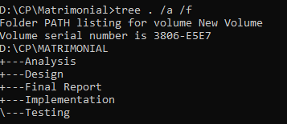Verification

Figure 7 Tree structure

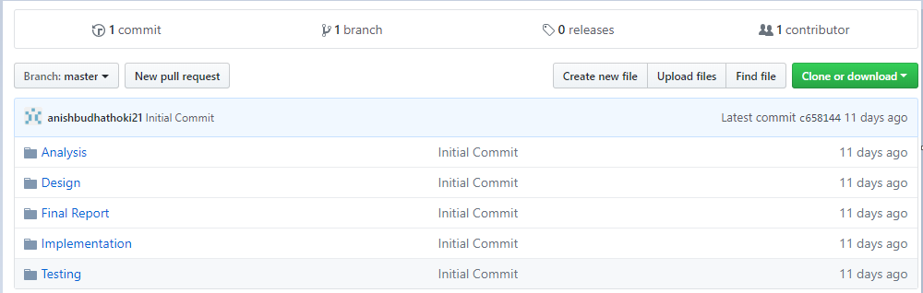Here we have used GitHub for version controlling. Version control is a system that records changes to a file or set of files over time so that we can recall a specific version when we want. Version Control helps to compare files, identify differences, and merge the changes if needed prior to committing any code. It helps to tack the milestone and progress of the system.

Figure File Repository in GitHub

# 7. Conclusion of project

All the required information has been gathered for the development of the system. Aims and objectives mentioned above defines how the result is going to look like. The main goal is to make a functional and running system.

Firstly, we defined the features, aim, objectives and limitations of the project. Also the methodology is also defined which is Waterfall model. The design pattern which we are using is MVC which is very flexible and fast. The proper scheduling and configuration management is also done for the project. At the end the system will be tested properly.

# References

Anon., 2019. *Code Academy.* [Online]   
Available at: www.codeacademy.com/articles/mvc  
[Accessed 05 01 2019].

Anon., 2019. *Jinfonet.* [Online]   
Available at: www.jinfonet.com/resources/bi-defined/3-tier-architecture-complete-overview/  
[Accessed 03 01 2019].

Anon., 2019. *Toolsqa.* [Online]   
Available at: www.toolsqa.com/software-testing/waterfall-model/  
[Accessed 05 01 2019].